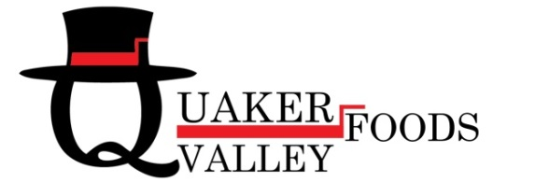

BI-LINGUAL (ENGLISH & SPANISH SPEAKING)

SALES TRAINEE / CUSTOMER SERVICE REPRESENTATIVE

Join our staff and come grow with Quaker Valley Foods, a refrigerated food distributor located in Northeast Philadelphia, as our Bilingual Sales Trainee/Customer Service Representative. We have an immediate opening for someone who is proficient in Spanish and English.

Recent college grads welcome to apply!

This opportunity is for someone with energy and personality to support a large, multi-cultural sales and buying team. The sales trainee/customer service representative will primarily assist in receiving and processing customer orders on a daily basis and entering them into the data entry system. The ability to effectively communicate over the phone is vital. This position requires inter-departmental interaction, working with the credit, transportation and operation departments. An extensive hands-on training program is provided.

Specific Duties will Include:
- Respond to customer phone inquiries in a prompt, courteous and concise manner
- Answer customer questions and assist in problem resolution
- Enter customer orders with accuracy and assure customer satisfaction
- Communicate customer requests to members of sales staff
- Assist the credit department in account set-up and customer billing
- Assist the sales and credit department with billing, return and collections issues
- Assist the transportation department with late orders and delivery issues
- Assist the sales department with communicating new items and pricing to customers
- Prospecting and opening targeted new business
- Account management
- Continued development of existing business

Desired Skills and Experience:
- College Degree preferred.
- Excellent verbal and written communication skills
- Attention to detail, and the ability to multi-task and manage productivity
- Knowledge of food industry preferred
- Proficient in Microsoft Word and Excel
- Ability to work a flexible schedule

Please send your resume WITH SALARY REQUIREMENTS to: careers@quakervalleyfoods.com.
Resumes without salary requirements will not be considered.
We are a drug-free workplace; criminal background checks are run on all potential candidates. No phone calls, please.
EOE

